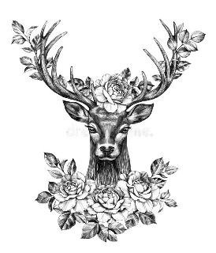

THE STAG’S HEAD

PUB & KITCHEN

**GLUTEN FREE MENU**

STAG NACHOS- TOPPED WITH CHEESE SAUCE, GUACAMOLE, SALSA, SOUR CREAM, JALAPENOS + PICKLED RED ONIONS V GF £8

DEEP FRIED HALLOUMI NUGGETS - WITH SWEET CHILLI DIP £7.50 ADD FRIES £5.50

THE STAG BURGER- TWO SMASHED BEEF PATTIES, AMERICAN CHEESE, SMOKED STREAKY BACON, LETTUCE, RELISH + PICKLES (GF BUN) £17

SPICED KEEMA LAMB BURGER- TOPPED WITH FETA, TZATZIKI, CHILLI JAM, LETTUCE + PICKLES (GF BUN) £18

ROAST CAULIFLOWER KATSU CURRY – WITH RICE, TOPPED WITH PICKLED RED ONIONS, SESAME SEEDS + RED CHILLIS V VG (N) GF £15

CAPRESE SALAD – BEEF TOMATO, BASIL, PULLED BUFFALO MOZZARELLA V GF £12

FRIES V VG GF £5.50

EXTRA CURRY SAUCE V VG GF £2

EXTRA GRAVY V VG GF £1.50

-DESSERT-

GF MANGO + RASPBERRY ETON MESS £8

-SUNDAY LUNCH-

SERVED SUNDAY 12-6PM OR WHILE STOCKS LAST

ROAST TOPSIDE OF BEEF £18

ROAST PORK LOIN £18

½ ROAST CHICKEN £16.50

ALL OUR ROASTS ARE SERVED WITH ROASTIES, SEASONAL VEG + HENDOS GRAVY